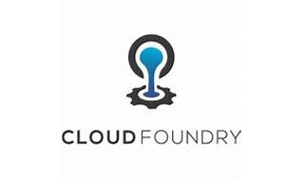

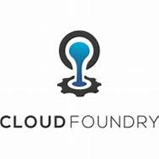

Explore

**Cloud Foundry** is an opinionated application platform that brings efficiency, security, and speed to software development organizations. [It simplifies building, testing, deploying, and scaling applications, offering a choice of underlying infrastructure (including Kubernetes), developer frameworks, and application services1](https://tutorials.cloudfoundry.org/what-is-cf/docs/what-is-cf/).

Here are **five free resources** where you can learn more about Cloud Foundry:

1. **Introduction to Cloud Foundry (LFD132x) on edX**: This self-paced online course provides an overview of Cloud Foundry, its use cases, and its relationship with Kubernetes. [It covers the impact on developers, operations, and security teams](https://tutorials.cloudfoundry.org/what-is-cf/docs/what-is-cf/)[2](https://www.cloudfoundry.org/blog/free-intro-to-cloud-foundry-online-course/).
   * [Learn more](https://www.edx.org/learn/cloud-foundry/the-linux-foundation-introduction-to-cloud-foundry)
2. **Cloud Foundry Overview**: Explore the basics of Cloud Foundry and how it works. [This resource explains how cloud platforms allow deploying network apps or services quickly](https://tutorials.cloudfoundry.org/what-is-cf/docs/what-is-cf/)[3](https://docs.cloudfoundry.org/concepts/overview.html).
   * [Read more](https://docs.cloudfoundry.org/concepts/overview.html)
3. **Cloud Foundry Tutorials & Training**: Curated by the Cloud Foundry community, this tutorial hub covers the fundamentals of Cloud Foundry and related cloud-native technologies. [Learn how to run your workloads on the platform from your web browser](https://tutorials.cloudfoundry.org/what-is-cf/docs/what-is-cf/)[4](https://www.cloudfoundry.org/get-started/).
   * [Get started](https://www.cloudfoundry.org/get-started/)
4. **Free Intro to Cloud Foundry Online Course**: Created by the Cloud Foundry Foundation and Linux Foundation Training, this course dives into deploying cloud-native applications using Cloud Foundry. [It’s suitable for both technical and non-technical professionals](https://tutorials.cloudfoundry.org/what-is-cf/docs/what-is-cf/)[2](https://www.cloudfoundry.org/blog/free-intro-to-cloud-foundry-online-course/).
   * [Enroll here](https://www.cloudfoundry.org/blog/free-intro-to-cloud-foundry-online-course/)
5. **Cloud Foundry Wikipedia Page**: For a comprehensive overview, check out the Wikipedia article on Cloud Foundry. [It covers usage, continuous delivery, and its container-based architecture](https://tutorials.cloudfoundry.org/what-is-cf/docs/what-is-cf/)[5](https://en.wikipedia.org/wiki/Cloud_Foundry).
   * [Read on Wikipedia](https://en.wikipedia.org/wiki/Cloud_Foundry)

Happy learning! 🚀